Augmented Reality Simulator

Purdue University

Cornell Cup 2014

Stephen Carlson

Steven Ellis

Thor Smith

Table of Contents

1 Challenge Definition 1

2 Project Solution 2

2.1 Customer Value Proposition 2

2.2 Changes from Original Proposal 2

2.3 Key Technical Elements 2

3 Product Performance Evaluation 4

3.1 Performance Metrics 4

3.2 Failure Analysis 5

4 Technical Documentation 6

4.1 Component Selection Rationale 6

4.1.1 Cost Requirements 6

4.1.2 Microcontroller 6

4.1.3 Motherboard 7

4.1.4 Sensors 7

4.1.5 Wireless Communication 8

4.1.6 Display 8

4.2 Hardware Design Considerations, Phase 1 9

4.2.1 Power 9

4.2.2 Packaging 10

4.2.3 Printed Circuit Board 10

4.2.4 Microcontroller Layout 11

4.2.5 Power Supply Layout 12

4.2.6 Fabrication and Testing 13

4.3 Hardware Design Considerations, Phase 2 13

4.3.1 Power Supply 13

4.3.2 Sensor Printed Circuit Board 14

4.3.3 Power Supply Printed Circuit Board 14

4.4 Software Design Considerations 15

4.5 Software Design Considerations 15

The Software on the DE2i-150 is divided into five modules. Each module communicates to the other modules using sockets. Sockets were chosen over memory mapping because data sent between modules closely resembles packets. The Simulation logic is one of the key modules because it is swappable with other logic simulations using a common application programming interface. This allows third party sources to write simulations for our hardware without needing to compile with any of our other modules or understand how each module provides its information. The *Networking* and *Sensor Data* modules are combined in the same executable. 15

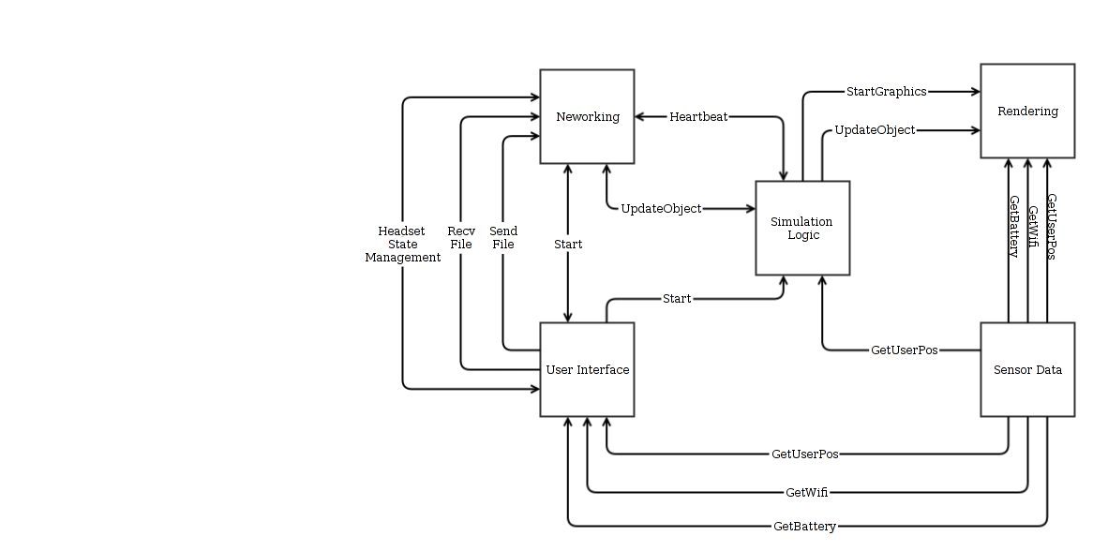 15

4.5.1 User Interface 15

4.5.2 Networking 18

4.5.3 Sensor Data 18

4.5.4 Simulation Logic 19

4.5.5 Rendering 19

5 Project Execution 22

5.1 Timeline 22

5.1.1 Adjustments 24

5.2 Budget 24

5.2.1 Bill of Materials 24

5.2.2 Expenditures 25

5.2.3 Funding Sources 25

5.3 Mid-Review 25

5.4 Process Understanding 25

6 Recommendations and Next Steps 26

7 Glossary 27

8 References 28

9 Acknowledgements 31

10 Survey Responses 32

11 Appendix 33

11.1 Test Plans 33

11.1.1 One-To-One Sizing and Placement Test 33

11.1.2 PCB Continuity and Functionality Test 34

11.1.3 Power Supply Burn-In 35

11.1.4 Total Runtime Test 35

11.1.5 Wireless Range Test 36

11.1.6 Wireless Latency Test 36

11.1.7 GPS Total Accuracy Test 37

11.1.8 GPS Relative Accuracy Test 38

11.1.9 Head Tracking Test 38

11.1.10 Brightness, Contrast, and Color Reproduction Test 39

11.1.11 Maximum Simultaneous Devices Test 39

11.1.12 Multiple Headset Test 39

11.2 Assembly and Construction 39

11.2.1 Rail Assembly 39

11.2.2 Display Assembly 39

11.2.3 Reflector 40

11.2.4 Sensor Assembly 40

11.2.5 Mounting the PCB to the enclosure 40

11.2.6 Mounting the enclosure to the rail 40

11.2.7 Materials required 40

11.3 Schematic Diagrams 40

11.4 Printed Circuit Board Layouts 40

11.5 Failure Mode Worksheet 41

# Challenge Definition

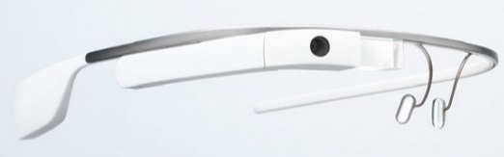Wearable computing is quickly becoming the next step of embedded systems evolution. Devices like Google Glass [1] as shown in Figure 1 and the Samsung Galaxy Gear aim to make computing part of everyday life. However, existing wearable devices are designed to serve as omnipresent gateways to the Internet and are not intended to work together in a collaborative real-time application with multiple users. As an alternative, this team proposes an immersive augmented reality platform which offers new multi-user applications for wearable computing. Such a device would have broad applications in education, defense, group recreation, and artistic performances where small teams of users can work together in the same augmented reality environment.

Figure 1: Google Glass, an existing wearable computing product

Portability and ergonomic challenges will primarily influence project development, as competing devices are often chosen for small size and low power consumption. A good solution to this challenge must have long battery life and a low mass to promote long-term wearable usage patterns. The virtual environment will not replace the real environment, so an ideal solution must also allow the user to perceive the real world with minimal eye strain or peripheral vision obstruction. Since augmented reality systems aim to overlay objects onto real-world positions, a successful device must be able to determine the position and orientation of the user in three-dimensional space within at least a few meters of precision.

This device must be capable of wireless communication with other augmented reality devices in close proximity to enable multi-user applications, where more than one user can share the same virtual environment. From a user perspective, ergonomics are also a major concern for wearable devices; the challenge is incorporating the desired functionality while not creating an unnecessarily heavy or bulky device. A successful device must also be durable enough to withstand regular use while not requiring technically experienced users for support.

While the software to support an augmented reality application will be dependent on the eventual usage case, the operating system which configures the headsets and handles common functionality like wireless networking and sensor processing must be easy to set up and use. For a non-technical user to understand the device, the application must start automatically on power up and walk the user through any initial setup process such as wireless pairing or sensor calibration. Custom applications which are written for this device should maintain a consistent state across any and all participating users and update the displayed virtual world at timely intervals.

# Project Solution

## Customer Value Proposition

End customers using this device will be able to experience a novel form of playing games that has not yet been realized by any system in the past. The user will be able to physically walk through a game and interact by colliding with virtual objects.

## Changes from Original Proposal

There have not been any significant changes from our original proposal.

## Key Technical Elements

There are four key technical elements to this presentation. The first element is the sensor printed circuit board (PCB) which contains the inertial measurement unit and the global positioning system sensors. This is mounted in the back of the headset and it is used to track the position of the player and the orientation of the player’s head. This is shown as the *GPS Receiver* and *IMU* in Figure 2 below.

The second element is the headset packaging itself, labelled *Headset* and *Display* in Figure 2. A hard hat provides an adjustable fit to a variety of different heads and the mounting points for the sensor board and the LCD screen. The LCD screen is mounted in a black box at the front of the helmet and the screen is reflected off of a reflective film on a slanted piece of acrylic. Aluminum rods are used to make the front and rear mountings possible.

The third element is the power supply board that was built to accompany the DE2i-150 and make it mobile. This component is indicated by the *Power Supply*, *Fuel Gauge*, and *Battery* in Figure 2. The power supply board provides the means for tracking the battery status over USB and powering the DE2i-150, the LCD, and the sensor board. Finally, the fourth element is the key software modules built to perform the tasks of networking the helmets together, harvesting sensor data, displaying the user interface, rendering the 3D graphics, and running a simulation. This is indicated by the *Augmented Reality Application* and *Viewport Algorithm*.



Figure 2: Block diagram of the Augmented Reality Simulator system

# Product Performance Evaluation

## Performance Metrics

The experience of the end user will determine the satisfactory completion of the challenge, so frequent testing will be performed at multiple stages of the design to incorporate feedback from non-technical users. Project success will primarily be measured by the criteria shown in Table 1. Table 2 shows performance metrics specifically targeted towards software.

Table 1: Augmented reality system performance measures and satisfactory design metrics

| Metric | Target | Description |
| --- | --- | --- |
| Mass | Headset: 1 kg  Backpack: 3 kg | Neither the headset nor the backpack can be too heavy to impede the performance of typical activities by the user. |
| Power | 3 hours runtime | Augmented reality applications run for long durations, so the device must operate long enough on battery power to be usable. The remaining battery capacity should be displayed to the user. |
| Location | Minimum 2 meter accuracy and precision | The accuracy of the rendered virtual world depends heavily on the accuracy and precision of the user’s geospatial position. |
| Wireless | 80 m range, line of sight | A unique feature of this device is the wireless coordination capability of multiple headsets in the same virtual environment. The current wireless signal strength should be reported to the user. |
| Comfort | No running speed or vision reduction | Ideally, the user would be able to perform actions without a noticeable burden on the user. It is difficult to quantitatively measure comfort, but the user should be able to orient their head, see the environment, and move from place to place as effectively as if the device was not worn. |
| Durability | Operate from 0 to 40 C indoors and outdoors in dry conditions | Most augmented reality applications involve users walking or running, which will subject the device to vibration and light impacts. In addition, sunlight, humidity, and dust are inherent concerns for a portable device. |
| Usability | End user can start up and use device without a technician | A user unfamiliar with the device technical details must be able to power on the device, perform start-up procedures such as wireless connection, and load the desired application. |

Table 2: Augmented Reality Software Performance Metrics

| Metric | Target | Description |
| --- | --- | --- |
| 3D Graphics | Minimum 5000 polygon count | The user will expect to see a good 3d image. Phase 2 offers opportunities to increase graphical performance. |
| Graphics | Minimum 20 Hz update rate | We will need to render ghosts and the maze walls in real time according to the user’s geospatial location and their head orientation. |
| Collision Detection | Minimum 2 meter accuracy and precision | The ability of the software to detect collision detection will be affected by the accuracy of the GPS. The minimum required to be meaningful cannot exceed a couple of meters. This means ghosts could be 2 m2 to account for accuracy of GPS. |
| Network  User Position Update Rate | Minimum of 20Hz (50ms). | The position and orientation of each headset will need to be communicated wirelessly at least every 50ms to keep up with the GPS and provide meaningful feedback about collisions to each headset. |
| Network  Graphic Position Update Rate | Minimum of 20Hz  (50ms) | The position information about positions of ghosts and other virtual objects needs to be updated in a timely manner and should at least be as fast as the update rate of the player’s position. |
| User Interface Usability | End user can navigate the user interface intuitively. | A user unfamiliar with the operation of the software should be able to figure it out with minimal references to the user manual. For phase 1 this will be displayed from the control unit. In phase 2 the user interface will migrate to the headset’s display. |

## Failure Analysis

# Technical Documentation

## Component Selection Rationale

Innumerable decisions were involved when choosing parts for all project aspects, so the most important component selections for meeting project metrics are shown below.

### Cost Requirements

An initial estimate of $300 per headset and the budget shown in section 5.2.3 was used to guide parts selection. Cost is secondary to other project metrics due to the dearth of comparable devices on the market; price was only used to differentiate otherwise similar design choices. For example, Google Glass [1], a product with higher quality compact optics, is currently priced at $1500, and several other augmented reality products such as ARQuake [2] and CastAR [3] have not left development. In addition, the development expenses incurred are likely to be very different than actual production costs.

### Microcontroller

Processing power is the biggest concern for the headset microcontroller selection. Decoding and filtering the 9 degree of freedom inertial measurement unit (IMU) data into the user’s head orientation requires floating point math, and high-speed IMU filtering with low latency and timing jitter leads to better head tracking performance. Power consumption is secondary as other parts will dominate power use. The microcontroller must be able to handle each sensor connection as shown in Figure 2 and Table 3.

Table 3: Required on-chip microcontroller peripherals for headset

|  |  |  |  |  |
| --- | --- | --- | --- | --- |
| Device | Peripheral | Special Features | Minimum Speed | Pin Count |
| Motherboard | SPI | Master Mode, Chip Select | 800 KHz | 4 |
| GPS | Serial |  | 38.4 Kbaud | 2 |
| Fuel Gauge, IMU | I2C | Open-Drain, Current Sink | 400 KHz | 2 |
| Wireless | Serial | Full Duplex | 115.2 Kbaud | 2 |
| Future Expansion | GPIO | Configurable Data Direction | *N/A* | 10 |
|  |  |  | **Minimum Pins:** | 20 |

Table 4 shows the microcontrollers which were considered, all of which met the constraints for on-chip peripherals and pin count.

Table 4: Decision matrix for headset microcontrollers

|  |  |  |  |  |  |  |  |
| --- | --- | --- | --- | --- | --- | --- | --- |
| Part | I/O | RAM | Flash | Clock | DMA | Special Features | Cost |
| STM32F405RGT6 | 51 | 192K | 1M | 168MHz | 16 | Floating Point Unit | $11 |
| PIC32MX695F512H | 53 | 128K | 512K | 80MHz | 8 |  | $10 |
| ATSAM4S16BA-AU | 47 | 128K | 1M | 120MHz | 22 |  | $10 |

The STM32F405 microcontroller was chosen for Phase 1 due to the availability of a low cost $15 development board [4] and its very high performance, particularly with single cycle floating point operations. This chip also features extra RAM and processing power for future expansion. For Phase 2, this microcontroller was re-used, as it was available on hand and allowed reuse of the project code base from Phase 1.

### Motherboard

The headset GPU motherboard must have a compatible SPI port to interface with the microcontroller over SPI as described above. It also must support a standard display output such as VGA, composite, or HDMI for rendering to a commercially available screen. A second available standard interface such as USB is also preferred for debugging and to allow future expansion to other user input devices for more advanced simulations.

As the graphics processing motherboard is the largest power consumer on the device, low power consumption is mandatory. Small size and light weight is also important for a portable device. By comparison, performance is much less of a concern. The motherboard should also feature a USB port and SPI interface for connection to the microcontroller.

Table 5: Decision matrix for motherboards

|  |  |  |  |  |  |  |
| --- | --- | --- | --- | --- | --- | --- |
| Part | Idle Power | RAM | USB | SPI | Clock | Cost (board) |
| Raspberry Pi Model A | 2 W | 256M | 1 | 1 | 700MHz | $25 |
| BeagleBone Black | 2 W | 512M | 1 | 2 | 1GHz | $45 |
| Intel® Atom™ Board | 12 W | 2G | 4 | 1 | 1.8GHz | $150 |

As shown in Table 5, the Raspberry Pi Model A was chosen in Phase 1 for its low power consumption, cost, and outstanding community support. Prolific examples can be found on the Internet for the Raspberry Pi, whereas the BeagleBone Black is new and difficult to acquire.

Phase 1 exposed the limitations of the Raspberry Pi Model A motherboard. Although its low power consumption led to long battery life, the graphics processing unit on board was extremely difficult to use. Tasks such as displaying text and loading graphical models were extremely slow, impeding refresh rate metrics.

With the contribution of two Intel® Atom™ Terasic DE2i-150 boards from the Cornell Cup sponsors, the motherboard criteria were revisited. Due to the simplicity of coding graphics on the standard OpenGL framework for the Intel® Atom™ board, the Atom™ motherboard was chosen for Phase 2, with the higher power consumption and mass accepted as a necessary cost.

### Sensors

Due to advancements in MEMS technology, most inertial measurement units provide excellent noise performance and accuracy. Power consumption is not an issue as other parts will dominate power use. A breakout board must be available since most IMUs come in LGA packages that cannot be soldered by processes easily available to students.

Table 6: Decision matrix for 9-degree of freedom inertial measurement unit (IMU)

|  |  |  |  |  |  |
| --- | --- | --- | --- | --- | --- |
| Part | Gyro | Accelerometer | Compass | Resolution | Board Cost |
| STEVAL-MKI108V2 | L3GD20 | LSM303DLHC | LSM303DLHC | 16/16/12 bits | $27 |
| MPU-9150 | MPU-9150 | MPU-9150 | MPU-9150 | 16/16/13 bits | $50 |
| SparkFun IMU | ITG3200 | ADXL345 | HMC5883L | 16/13/12 bits | $50 |

As seen in Table 6, the slightly increased resolution of the MPU-9150 is offset by its cost and lack of documentation, particularly for the use of its powerful internal filtering algorithms [5]. The cheaper STMicroelectronics part [6] was chosen instead for Phase 1 and Phase 2, as it offered no apparent disadvantages to the expensive SparkFun 9-DOF sensor stick [7].

Past senior design groups experienced problems with low resolution and slow updates from GPS. The real-time constraints of this project call for a fast and high-resolution receiver module. Power consumption is also a concern, as the GPS unit will always be tracking the user.

Table 7: Decision matrix for GPS receiver unit

|  |  |  |  |  |  |  |
| --- | --- | --- | --- | --- | --- | --- |
| Part | Resolution | Update Rate | Accuracy | Antenna | Power Use | Cost |
| Venus638FLPx | ~0.5m | 20Hz | 2m | External | 29 mA | $50 |
| GP-635T | ~1m | 5Hz | 2m | Integrated | 56 mA | $40 |

The recently released Venus638FLPx vastly outperforms comparable units [8] due to its excellent resolution and astonishing 20Hz update rate as shown in Table 7. Real-world tests in section 11.1.7 confirmed the superior reception of this GPS receiver and its external antenna, leading to its selection for both the Phase 1 and Phase 2 headsets.

### Wireless Communication

Wireless communication keeps the individual headsets connected throughout the simulation. High reliability and low latency are paramount to meet the real-time requirements of the simulation. The wireless device must also transmit a minimum of 6-8 KB per second of data to meet the simultaneous device metrics, and must be able to report the signal quality and strength. A range of 150 yards line of sight will handle most simulations.

The wireless modules considered are listed in Table 8. Range tests as described in section 11.1.5 indicated that extremely large antennas are required to obtain the advertised range on many RF communications modules, so the observed range for each device is shown.

Table 8: Decision matrix for Phase 1 wireless communication devices

|  |  |  |  |  |
| --- | --- | --- | --- | --- |
| Part | Data Rate | Range (LOS) | Latency | Cost |
| XBee Pro 900HP | 11.5 KB/s | 300 m | 50ms | $40 |
| nRF24L01+ | 25 KB/s | 100 m | 50ms | $20 |
| Wireless-N | 6 MB/s | 200 m | 80ms | $30 |
| Bluetooth and Cell Phone Network | 200 KB/s | 2 km | 500ms | $30 |

Despite the range and data rate advantages of offloading wireless to a cell network, the test in section 11.1.6 found its latency to be unacceptable for augmented reality. The XBee Pro was selected in Phase 1 for its superior range over the nRF24L01+ module [9], which may not reach the design metric of 80 m in real-world conditions.

With the inclusion of the Intel® Atom™ motherboard in Phase 2, the XBee Pro was dropped in favor of the motherboard’s built-in Wireless N module. The small decrease in range and increase in latency was compensated by the ease of use of standard 802.11 networking and the extreme increase in data rate, which allows more simultaneous devices connected and more complex simulations with higher graphics quality.

### Display

The Phase 1 motherboard, the Raspberry Pi, supports output over HDMI and composite video. With the typical requirements of low power consumption and light weight in mind, a screen intended for use in a car back-up camera was obtained [10] which massed only 80 g with its enclosure removed. The low cost of just $50 also contributed to this part’s selection.

After the completion of Phase 1, user testing revealed that the resolution and low brightness of this display led to trouble using the device in bright outdoor conditions. With the switch to a more capable graphics processing motherboard, a higher resolution display was sought that could address apparent 3D graphics performance.

Two displays from the same vendor were tested; one was brighter and had a higher resolution of [11], while the other one was cheaper and used slightly less power with a resolution of [12]. Display testing as shown in section 11.1.10 showed that both displays significantly improved brightness and contrast performance. If the challenges with graphics drivers discussed in [SECTION] are addressed, the higher-resolution display is the better choice due to its superior brightness and readability; otherwise, the lower resolution of the second display will lead to better head tracking latency performance as fewer pixels have to be redrawn every frame.

## Hardware Design Considerations, Phase 1

### Power

Power will be limited on the headset, as it will run on a lightweight single lithium ion cell worn by the user. The biggest power consumer will be the graphics processor and display used to render images. The wireless radio and GPS also consume power to send and receive data. By comparison, the current draw of the microcontroller, IMU, and other circuitry is negligible. Low-dropout linear regulators are required, since no available switch-mode regulator can efficiently convert a battery voltage as low as 3.7 V to the required 3.3 V as shown in Table 9.

Table 9: Power supply constraints and supply rails in use on Phase 1 headset

|  |  |  |  |  |
| --- | --- | --- | --- | --- |
| Supply Rail | Voltage | Current Required | Topology | Peripherals Powered |
| Vcore | 3.3 V | 500 mA | Linear | Graphics Processing |
| VMCU | 3.3 V | 350 mA | Linear | Microcontroller, Wireless, GPS |
| VADC | 3.3 V | 30 mA | Linear | IMU |
| VDISPLAY | 5 V | 300 mA | Switching | Display, USB |

With the estimated power requirements shown above, the battery size required to achieve the design metric run time of 3 hours can be calculated using the equation shown below. As a rule of thumb, 80% of a battery’s advertised capacity can be used. This equation was chosen for its simplicity and presentation for this application by the Senior Design advisors:

**Example**: For the Phase 1 headset data shown above, with = 3.7 V nominally for a 1-cell lithium ion battery and = 80% = 0.8, can be calculated as follows:

(η estimated from charts in [13])

Thus, a 3.7 V battery with a capacity will lead to an approximate 3 hour runtime. In reality, temperature and aging will reduce the actual runtime. The nearest readily available battery capacity was

To supply power at the right voltage, an appropriate voltage regulator was selected for each rail. Special attention was paid to the VADC regulator, as good line regulation and high ripple rejection reduce the noise seen by the IMU. A readily available voltage regulator from Micrel® [14] was found to meet all requirements to serve each of the 3.3 V supplies. The 5 V supply, being higher than the battery voltage, requires a switch-mode regulator. A low-cost power module [13] was found that met the design requirements in an easy-to-assemble package.

Two convenient choices were found for the Phase 1 battery, a SparkFun prismatic cell [15] and an Adafruit cylindrical cell pack [16]. Both batteries combined three smaller lithium polymer cells in parallel with a protection circuit to reduce fault current and prevent overcharging for improved reliability. While the Adafruit battery was slightly cheaper, the SparkFun cell had a much smaller form factor and weighed less, leading to its selection for improved portability.

### Packaging

The headset is designed to be portable and worn by the user. Of the peripherals in use, the display, inertial measurement unit, and antennas must be placed on the user’s head. An adjustable mount for the half silvered mirror and reflection shield must be provided to allow users with different head sizes to position the device for optimal viewing conditions. The device should be packaged in one unit with few exposed wires, as non-technical users should not be expected to plug in parts. Packaging must be able to withstand the vibration and impacts that are inevitable for wearable electronics, and must be able to tolerate outdoor temperatures.

### Printed Circuit Board

Due to the extensive use of surface mount components in this project, a custom-designed printed circuit board (PCB) was chosen as the most reliable method of implementing the schematic design. OSH Park, the manufacturer used by the Purdue Electrical Engineering department to outsource PCB production, quotes the minimum values shown in Table 10 for their standard specification designs. For optimal manufacturing yield and to allow tolerance for best practice, the PCB was designed with wider tracing and spacing and a larger drill size. In addition, acute angles and sharp corners were avoided, as these features can trap etchant during manufacturing and lead to broken traces on the final board.

Table 10: PCB specifications for OSH Park [17], 1 mil = 0.001 inch

|  |  |  |
| --- | --- | --- |
| Metric | Given | Chosen for Manufacturability |
| Trace Thickness | 6 mil | 10 mil |
| Trace Spacing | 6 mil | 8 mil |
| Drill Diameter | 13 mil | 15 mil |
| Drill Tolerance | 5 mil | *N/A* |
| Copper Thickness | 1 | *N/A* |

The form factor and connector placement were the most important requirements for the PCB. To properly mate with the Raspberry Pi as shown in Figure 3, the PCB dimensions and I/O header placement had to exactly match the motherboard mechanical specifications [18]. External connectors for USB charging, the battery, and the radio antennas also had to face outwards on the PCB edges to allow connections to the final packaging.

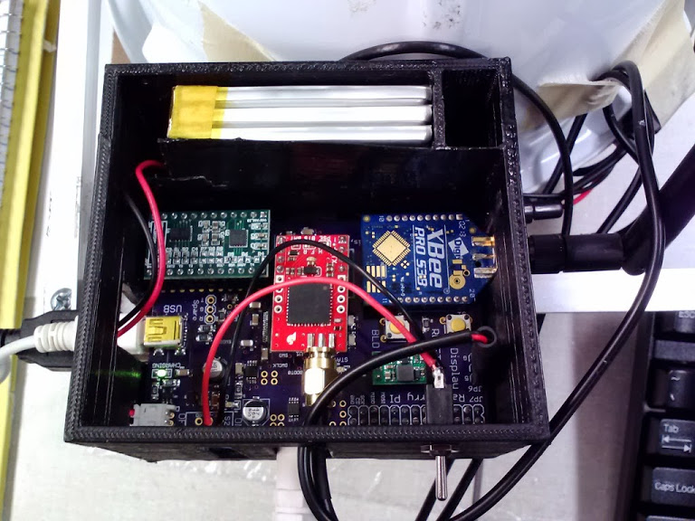

**Battery**

**Power Supply**

**GPS**

**IMU**

**XBee**

Figure 3: Finished printed circuit board in its packaging with major sections highlighted; the motherboard is stacked directly below the board shown

The major radio frequency emitters on this board contribute electromagnetic interference (EMI) which could disrupt the inertial measurement unit (IMU), but the noise magnitude decreases with the square of the distance. The global positioning system (GPS) unit has an external antenna [19] which moves its noise emissions far from the PCB, so the XBee radio and antenna [20] was placed in the lower left corner as far away from the IMU as possible.

To reduce power supply switching noise, this design used a power and ground plane along with 12 decoupling capacitors. These capacitors were placed near each supply pin as recommended by the manufacturer [21]. Noise caused by signal reflections can be attenuated by matching the USB and crystal oscillator to under the 0.05 inch tolerance [22] using the EAGLE “*run length-freq-ri*” tool. An image of the complete layout is attached in the [Appendix].

### Microcontroller Layout

The circuit board was designed using the EAGLE Layout Editor, which already contained the project schematics, but the built-in auto router produced unsatisfactory results. To make the PCB easier to route, pin assignments and part placements near the microcontroller were chosen to limit crossing signals as is shown in Figure 4. After final placement, spare I/O pins and a spare serial port were brought out to pads to enable debugging and future expansion.

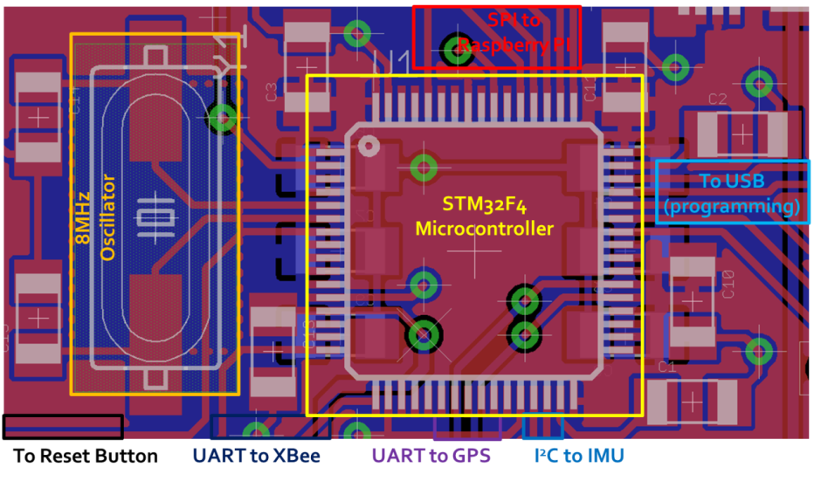

Figure 4: Signal routing near microcontroller showing oscillator circuit and peripheral connections

### Power Supply Layout

The power supply for this board must deal with a fluctuating load and battery management to maximize the device battery life while reducing the risk of device failure due to overheating. Total current could be up to 2 A during radio transmission events as evidenced by the design constraint analysis, so power supply traces were widened according to the trace heat equations shown below recommended by OSH Park to reduce resistive losses [23].

**Example**: is given to be (see Table 10) and of heating was allowed. Therefore, for a power supply trace carrying of current, the calculation of the minimum trace would be (1 mil = 0.001 inch):

Therefore, this trace should be no narrower than 0.031 inches to carry the rated current with less than the specified temperature rise. In practice, traces of twice the minimum width were selected wherever possible to reduce power loss from trace resistance and increase battery life.

Power and ground planes were emphasized to simplify power routing as is shown in Figure 5. The bottom of the board was devoted to a ground plane with few signal traces to reduce the size of noise-inducing ground loops. Power planes also provide heat dissipation paths with low thermal resistance for the regulator circuits, keeping them cool to increase reliability.

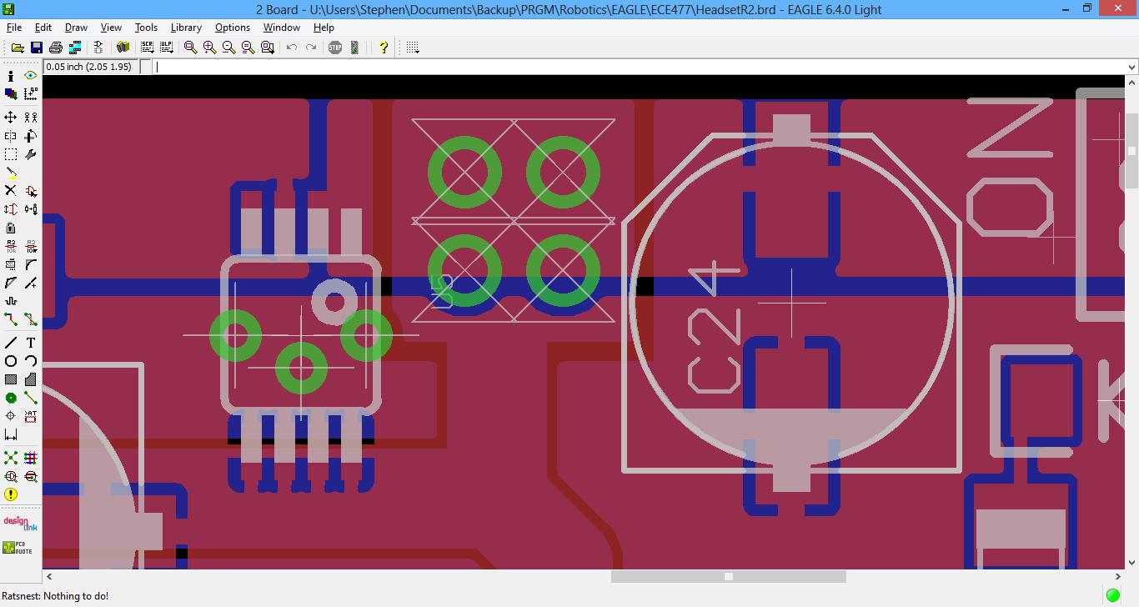

Figure 5: Close-up of power supply showing bulk capacitance and power planes

To reduce noise coupling between the IMU and the digital circuits, a separate low-dropout regulator with outstanding noise rejection was dedicated for the IMU power supply and placed close to it. Although the IMU communicates its results using a digital protocol that is resistant to interference, noise on the power supply can still disrupt the computed orientation [6]. This regulator does not have to power other loads, so switching noise is reduced. The step-up converter used to generate 5V for the display [13] was located far from the IMU to reduce its EMI coupling to the sensors.

### Fabrication and Testing

This custom board design used standard library parts, but one-to-one tests were conducted before PCB fabrication as shown in section 11.1.1 to verify that the parts on hand matched the prospective board. No discrepancies were noted in this test. After receiving the initial circuit board from the manufacturer, the first procedure involved electrical conductivity tests as described in section 11.1.2. Importantly, this test discovered an unwanted short from the IMU power supply to ground; continued conductivity measurements allowed location and repair of a hair-line copper filament shorting the target trace to a ground plane.

When the board had been tested, the power supply components were installed first to verify the operation of this important section of the board. Burn-in testing procedures as described in section 11.1.3 were applied for 24 hours at the rated design load, and the supply outputs continued to function at the desired voltages. After populating the remaining components, simple test programs were uploaded to the microcontroller to test each part of the board independently. Notable tests as mentioned in sections 11.1.8 and 11.1.9 included GPS location precision and IMU head tracking performance.

## Hardware Design Considerations, Phase 2

### Power Supply

With the introduction of the Intel® Atom™ board for powering the Phase 2 graphics rendering, a substantial revision to the power supply was required. As the necessary battery to achieve the design metrics became too heavy to meet the headset design mass, the entire power supply was moved to the backpack unit with the Atom™ board. Since the sensors need to remain on the user’s head, the Phase 1 PCB was bifurcated into a dedicated sensor board and a power supply board.

Another microcontroller with USB support was now required for the split power supply board to report the battery state of charge over USB to the Intel® Atom™ board. This microcontroller had to have low stand-by power consumption, as it monitors the state of charge even when the motherboard is powered off. The STM32L100RBT6 chip was chosen due to its design and programming similarity with the sensor microcontroller and its idle mode power consumption of less than 2 µA [24].

### Sensor Printed Circuit Board

Feedback from Phase 1 indicated that the head tracking system generally worked well. Phase 2 thus re-used a large fraction of the Phase 1 system board for handling the IMU and GPS sensors. The USB connector was re-purposed for communications with the Intel® board, and this opportunity was taken to reduce the PCB dimensions to lower the mass of the headset. Since the microcontroller was unchanged from Phase 1, the routing for that critical area of the PCB was also unchanged; see section 4.2.4 for details.

With the removal of the XBee, the peak current draw of the board now remains within the 500 mA USB maximum load [22]. A single 3.3 V voltage regulator sufficient to handle 500 mA now supplies the microcontroller and GPS [14] as shown in Figure 6. The separate regulator for the IMU was also retained in its original location.

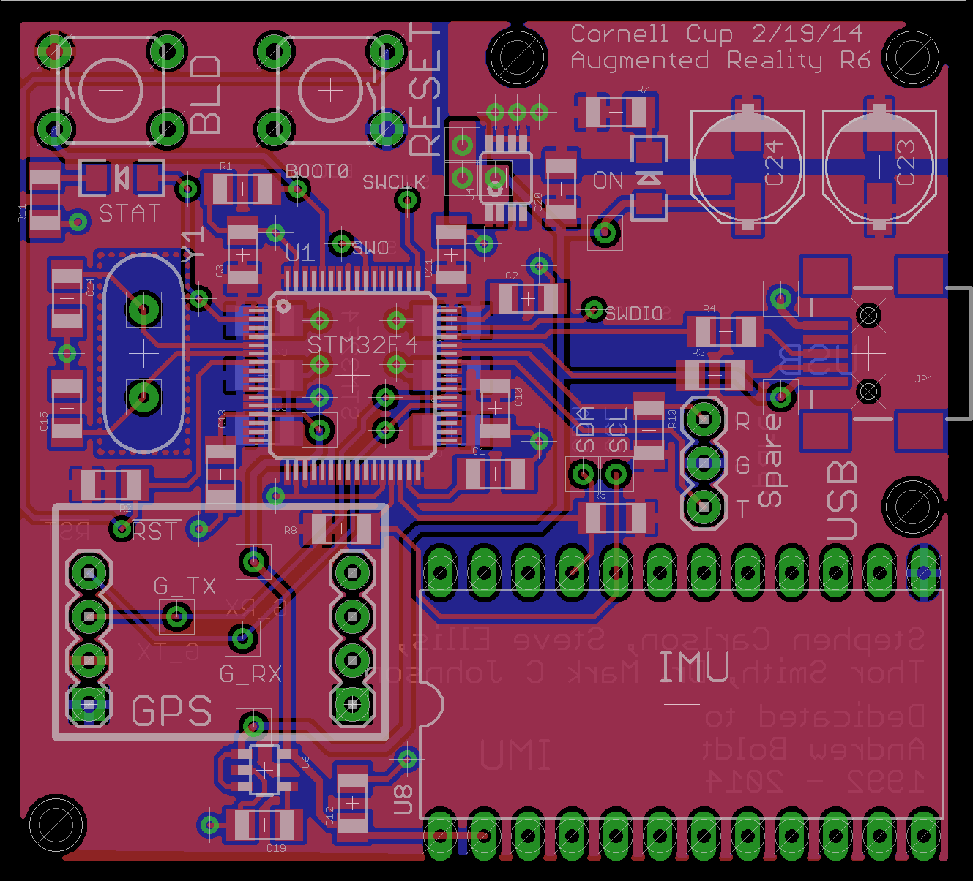

Figure 6: Power supply of the Phase 2 sensor PCB

After fabrication and population, testing as conducted in section 4.2.6 revealed no issues with this design. As the board was an evolution of the Phase 1 design, knowledge from that successful design proved invaluable to the rapid design and success of this PCB.

### Power Supply Printed Circuit Board

This board had a new design, needing to incorporate battery charging, monitoring, and voltage regulation for a much higher power system. Its mass was still a concern, as the backpack still had to target a wearable design mass. Connectors for USB communication, the battery, the charger, and the power output were also incorporated on the sides of the board. As this board was also fabricated by OSH Park, the specifications from section 4.2.3 were used.

## Software Design Considerations

## Software Design Considerations

The Software on the DE2i-150 is divided into five modules. Each module communicates to the other modules using sockets. Sockets were chosen over memory mapping because data sent between modules closely resembles packets. The Simulation logic is one of the key modules because it is swappable with other logic simulations using a common application programming interface. This allows third party sources to write simulations for our hardware without needing to compile with any of our other modules or understand how each module provides its information. The *Networking* and *Sensor Data* modules are combined in the same executable.



Figure : Diagram of software modules

### User Interface

A graphical application is provided to the user that allows them to either host a simulation or join an existing simulation.

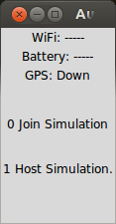

Figure : Select mode screen

The first screen shown in Figure 2 host option allows the user to select headsets that may participate in the simulation and then choose a simulation to launch. The join option allows the user to wait as their headset is automatically configured and displays important information about the state of the headset as it moves through the various stages of being accepted, receiving simulation information, and then starting the simulation.

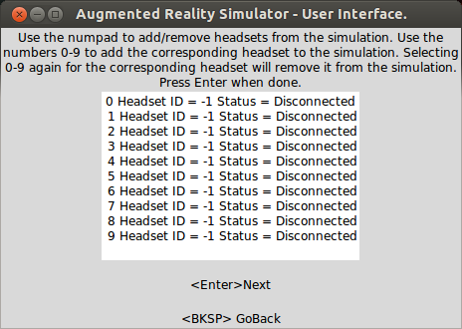

Figure 9: Select headset screen

The second screen if the host simulation option is picked is the Select Headsets screen shown in Figure 3. This screen allows the user to dynamically add and remove headsets that should be included in a simulation.

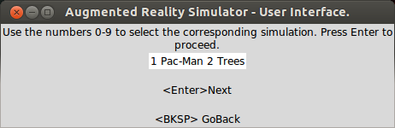

Figure 10: Select simulation screen

The third screen if the host simulation option is picked is the select simulation screen. This screen allows the user to pick amongst a set of simulations available. When the user proceeds to the next screen the simulation will be sent to all accepted headsets.

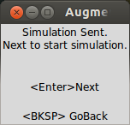

Figure 11: Start simulation screen.

The fourth screen if the host simulation option is picked is the start simulation screen. This allows each player to feel prepared before the actual simulation starts and after each user has received the simulation files.



Figure 12: Run simulation screen

The fifth screen that shows when the user selects the host simulation option is the run simulation screen. The user may not see this screen as the simulation is immediately launched, but this screen provides a way to keep track of the user’s status.

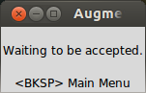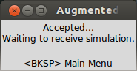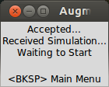

Figure 13: Simulation Screens for waiting to be accepted, waiting to receive simulation information, and waiting to start the simulation respectively.

If the join simulation option was selected, then the user will be taken through the three screens shown above. The transitions will happen automatically as the host proceeds through accepting and selecting the simulation options.

### Networking

The networking module abstracts away the details of sending and receiving information over the wireless network. This module will transition to various states depending on which initial state it is configured for by the User Interface (host or join). If the headset is configured to join, then it will begin by broadcasting itself as an available headset for a simulation. When accepted, it will wait to receive information about which simulation to use. After receiving the simulation information, it will wait for final confirmation to start the simulation. After starting, it will send out a periodic heart beat that tells the host about its current location and orientation. If the headset is configured as a host, then it will remain quiet on the network and listen for available headsets to add to a simulation, adding each headset it discovers to its list of available headsets. The User Interface will make calls to accept and reject headsets from the simulation. When the simulation starts, the networking code will continue to be silent until told to send out packets to control other headsets and to send out updates about 3d object positions and orientations.

### Sensor Data

The sensor data module is in the same executable as the networking module. This module simply holds the latest position and orientation information about the headset. It also performs arithmetic on the longitude and latitude coordinates received from the sensors to produce local coordinates x and y as follows. The meters per degree latitude is calculated based on the arc length of one degree of latitude. The meters per degree longitude is calculated as the arc length of one degree of longitude on a circular cross section of the earth at a given degree of latitude.



The x and y values are measured relative to an origin which is taken to be the first stable value out of the GPS after achieving a lock. The origin is always reset when starting a new simulation. This would be an absurd approximation for longitude if it was expected that someone using a headset would travel for a very long distance. For short distances of a couple hundred meters, these constants are adequate.

### Simulation Logic

A simulation is a python program that utilizes our python interfaces to start the graphics and to collect information about the user position and the position of other players. A series of functions and objects have been provided in this API to make development as simple as possible. This section was designed to be easy to prototype with. An extension of this section would provide the ability to write simulations in C++.

### Rendering

The 3D rendering portion of the software makes use of the open source library Irrlicht [25], which is based on OpenGL and provides a relatively simple interface for accomplishing common rendering tasks. When the rendering function starts, it is passed a configuration file from which it loads the initial state of the simulation. The main rendering loop then communicates with the sensor reading code to get the user’s location and orientation, and with the simulation code to get the locations of all the virtual objects to be rendered. This data is collected is collected once per frame, and then rendered. Additionally, the battery’s current state of charge and wireless signal strength are collected from the microcontroller and displayed to the user here.

Table 11: List of important software classes; full software documentation can be found in [Appendix]

|  |  |
| --- | --- |
| ./simulation_src/testApplication.py | Pacman Application |
| ./simulation_src/level/genlevel.c | Generates a config file from an ascii art file. |
| ./simulation_src/gpuPyInterface.py | A python sockets interface to the graphics rendering c++ code. |
| ./sensor_micro_src/src/main.c | The code for collecting GPS and IMU data. |
| ./gpu_src/render/genlevel.c | Generates a config file from an ascii art file. |
| ./gpu_src/render/main.cpp | Starts and runs all of the graphics rendering code. |
| ./gpu_src/render/normalScreen.sh | Script to un-invert the screen. |
| ./gpu_src/render/GameObject.h | Class that holds information about a specific 3d object being drawn on-screen. |
| ./gpu_src/render/invertScreen.sh | Invert the screen left-right |
| ./gpu_src/render/gpuPyThreadInterface.cpp | Serves as a sockets interface between the simulation python code and the rendering c++ code. |
| ./gpu_src/render/InputReceiver.cpp |  |
| ./gpu_src/render/Makefile |  |
| ./gpu_src/render/GameObject.cpp | Class that holds information about a specific 3d object being drawn on-screen. |
| ./gpu_src/render/SensorReader.cpp | Class that serves as a sockets interface to the networking/sensor process to collect users position. |
| ./gpu_src/render/interface.cpp |  |
| ./gpu_src/render/SensorReader.h | Class that serves as a sockets interface to the networking/sensor process to collect users position. |
| ./gpu_src/render/gpuPyThreadInterface.h | Serves as a sockets interface between the simulation python code and the rendering c++ code. |
| ./gui_src/textInfo.py | Text strings to display to the end user for instruction. |
| ./gui_src/launch.py | The GUI used by the end user. |
| ./gui_src/guiNetInterface.py | The sockets interface between the GUI and the networking/sensor code. |
| ./networking_src/networking_daemon.cpp | The code that starts the networking threads and sensor data collection threads. |
| ./networking_src/packetStrings.py | Python script to auto-generate packets.c/h |
| ./networking_src/packetLib.cpp | Contains all of the networking functions and associated data. |
| ./networking_src/threadInterface.h | Serves as a sockets interface to any code module talking to the networking or sensor code. |
| ./networking_src/Makefile |  |
| ./networking_src/gpsIMUDataThread.cpp | This code collects GPS and IMU sensor data from the sensor board over UART. |
| ./networking_src/gpsIMUDataThread.h | This code collects GPS and IMU sensor data from the sensor board over UART. |
| ./networking_src/threadInterface.cpp | Serves as a sockets interface to any code module talking to the networking or sensor code. |
| ./networking_src/packetLib.h | Contains all of the networking functions and associated data. |
| ./networking_src/generatePackets.py | Python script to auto-generate packets.c/h |

# Project Execution

## Timeline

The timeline and milestones can be seen in the figures below. Each task in the timeline is color coded according to what category it belongs. These categories have been chosen because they logically separate pieces of the design and separate tasks that different team members are expected to accomplish. Multiple tasks are overlapped with each other to demonstrate which parts of the project could have been completed concurrently.

The timeline is divided into two sections denoted as *Phase 1* and *Phase 2*. *Phase 1* refers to the first iteration of the project which was implemented for a senior design project. This iteration helped the team to get an idea of what the final outcome would look like and to get a feel for the challenges that we faced in designing the second iteration.

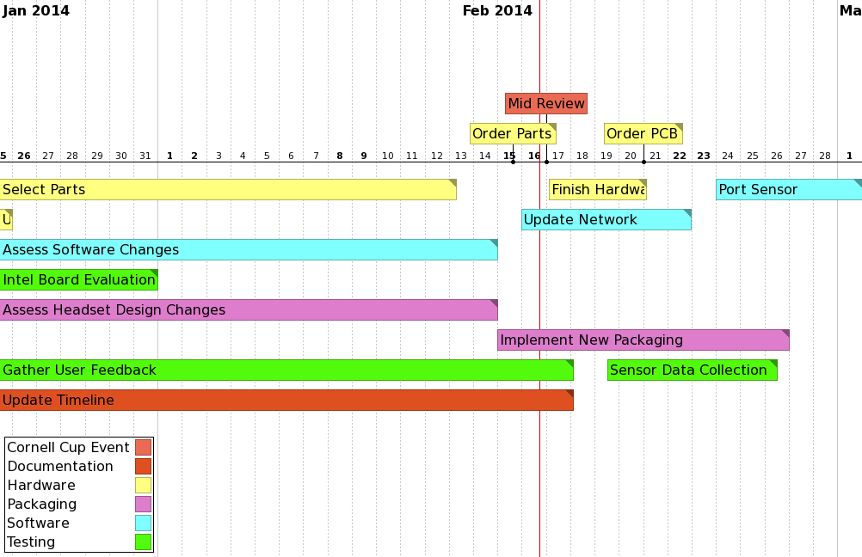

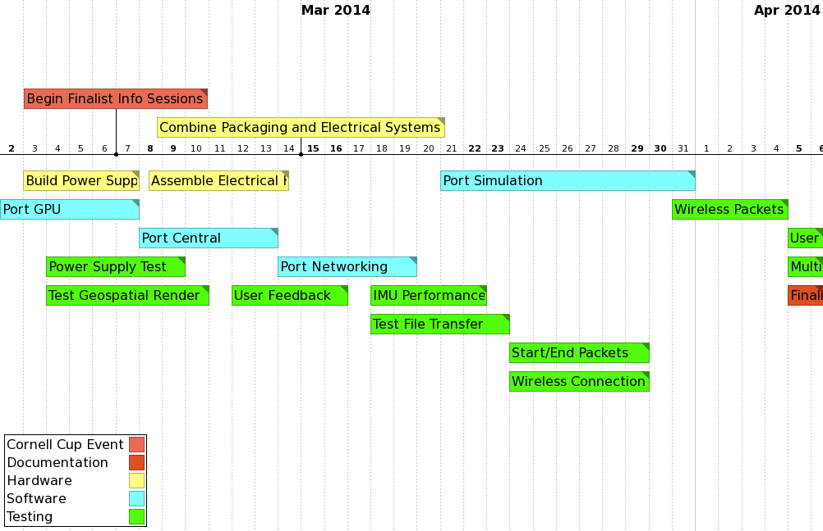

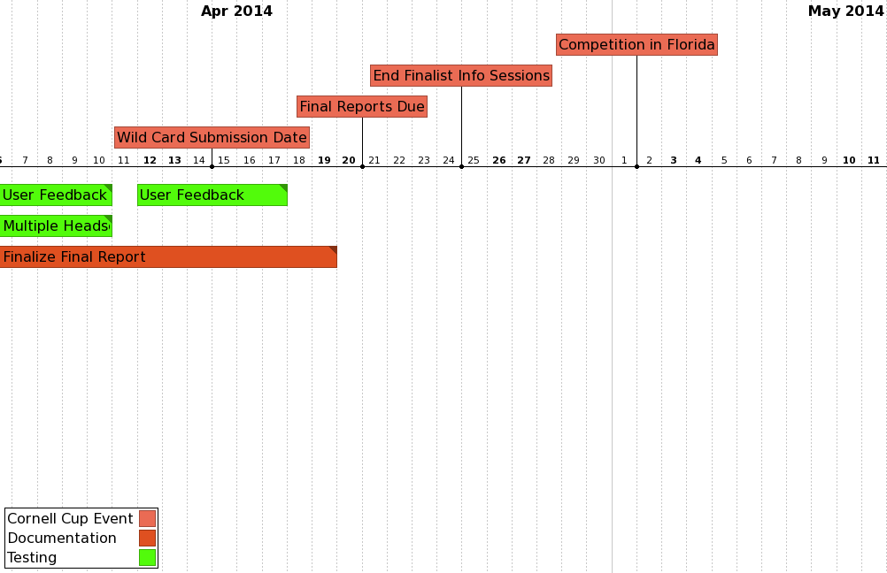

### Adjustments

## Budget

### Bill of Materials

Table 12: Bill of materials for Phase 2 design

|  |  |  |  |  |  |  |
| --- | --- | --- | --- | --- | --- | --- |
| Digi-Key Part Number | | Description | Footprint | # | Per Unit | Cost |
| LVK12R010DERCT-ND | | Res 0.5W 10mOhm | 1206 | 1 | $0.50 | $0.50 |
| 490-6521-1-ND | | Cap 4.7uF 50V Ceramic | 1206 | 3 | $0.76 | $2.29 |
| P16460CT-ND | | Cap 180uF 16V Low ESR | Panasonic E | 1 | $2.32 | $2.32 |
| 490-3367-1-ND | | Cap 2.2uF 50V Ceramic | 1206 | 2 | $0.39 | $0.78 |
| CTX406-ND | | Crystal 8MHz 20pF | HC-49US | 2 | $0.36 | $0.72 |
| 160-1889-1-ND | | LED Blue | 1206 | 1 | $0.38 | $0.38 |
| 475-1407-1-ND | | LED Green | 1206 | 2 | $0.11 | $0.22 |
| P68.1KBCCT-ND | | Res 68.1K 0.1% | 1206 | 1 | $0.79 | $0.79 |
| P5.76KBCCT-ND | | Res 5.76K 0.1% | 1206 | 1 | $0.79 | $0.79 |
| P100KBCCT-ND | | Res 100K 0.1% | 1206 | 1 | $0.79 | $0.79 |
| P34KBCCT-ND | | Res 34K 0.1% | 1206 | 1 | $0.79 | $0.79 |
| P499KBCCT-ND | | Res 499K 0.1% | 1206 | 1 | $0.79 | $0.79 |
| P215KBCCT-ND | | Res 215K 0.1% | 1206 | 1 | $0.79 | $0.79 |
| P2.43KBCCT-ND | | Res 2.43K 0.1% | 1206 | 1 | $0.79 | $0.79 |
| ED2992CT-ND | | Mini USB Connector | Special | 2 | $0.87 | $1.74 |
| 497-11767-ND | | STM32F405RGT6 | TQFP 64 | 1 | $11.45 | $11.45 |
| 497-13631-ND | | STM32L100RBT6 | TQFP 64 | 1 | $4.37 | $4.37 |
| 576-1827-5-ND | | Regulator 3.3V 500mA | MSOP 8 | 1 | $2.35 | $2.35 |
| 576-1281-1-ND | | Regulator 3.3V 150mA | SOT-23-5 | 1 | $2.01 | $2.01 |
| LM2936MP-3.3/NOPBCT-ND | | Regulator 3.3V Low-Iq | SOT-223-4 | 1 | $1.78 | $1.78 |
| DS2782E+-ND | | Fuel Gauge IC | TSSOP 8 | 1 | $7.46 | $7.46 |
| 296-20523-ND | | Power Module 12V 3A | Special | 1 | $17.70 | $17.70 |
| 497-12918-ND | | 9-DOF IMU Breakout | DIP 24 W | 1 | $27.60 | $27.60 |
|  | |  |  |  |  | $89.20 |
| Items available from the Senior Design lab include: | | | |  |  |  |
|  | Cap 0.1uF Ceramic | | 1206 |  |  |  |
|  | Cap 1uF Ceramic | | 1206 |  |  |  |
|  | Header Breakaway Female | | 0.1 |  |  |  |
|  | Header Breakaway Male | | 0.1 |  |  |  |
|  | Res 4.7K 5% | | 1206 |  |  |  |
|  | Res 10K 5% | | 1206 |  |  |  |
|  | Res 6.8K 5% | | 1206 |  |  |  |
|  | Res 22 5% | | 1206 |  |  |  |
|  | Res 1.5K 5% | | 1206 |  |  |  |
|  | Cap 39pF Ceramic | | 1206 |  |  |  |
|  | Cap 470pF Ceramic | | 1206 |  |  |  |
|  | Cap 10uF 16V | | Panasonic D |  |  |  |
|  | Cap 22uF 16V | | Panasonic D |  |  |  |
|  | PCB Button | | Special |  |  |  |

### Expenditures

### Funding Sources

Table 13: Sources of funding for Phase 2 design

|  |  |
| --- | --- |
| Cornell Cup | $1500 |
| Purdue University | $300 |

## Mid-Review

## Process Understanding

# Recommendations and Next Steps

# Glossary

* **Augmented reality**: a system which overlays a computer generated image on top of real world objects so that both are simultaneously perceptible
* **Global positioning system (GPS)**: a sensor which receives signals from a global network of satellites to determine absolute position on the Earth’s surface
* **Electromagnetic interference (EMI)**: a disturbance in an electrical circuit induced by electromagnetic radiation from other circuits in proximity
* **Equivalent series resistance (ESR)**: the non-ideal resistance of real electrical components, acting as if this resistance value was placed in series with the device
* **Inertial measurement unit (IMU)**: a sensor which reports velocity, orientation, and gravitational forces
* **Inter-integrated circuit interface (I2C)**: a two-wire bidirectional synchronous serial communications system which connects multiple *master* and *slave* electronic parts through an addressable protocol
* **Jitter**: the unwanted, often random, timing deviation of a periodic waveform from its expected period
* **Printed circuit board (PCB)**: a substrate which supports and connects electrical components through an etched network of conductive traces
* **Serial peripheral interface (SPI)**: a fast four-wire bidirectional synchronous serial communications protocol used to interface two or more electronic parts
* **Turnkey startup**: the ability of a device on power-up to autonomously enter a state where a non-technical user can continue use of the device
* **Virtual reality**: a system which fills the user’s entire field of view with a computer generated image to the exclusion of the real world

# References

|  |  |
| --- | --- |
| [1] | M. I. Olsson, M. J. Heinrich, D. Kelly and J. Lapetina, "Wearable device with input and output structures". United States of America Patent 20130044042, 18 August 2011. |
| [2] | B. Thomas, B. Close, J. Donoghue, J. Squires, P. De Bondi and W. Piekarski, "First Person Indoor/Outdoor Augmented Reality Application: ARQuake," *Personal and Ubiquitous Computing,* vol. 6, pp. 75-86, 2002. |
| [3] | M. Perenson, "Augmented-Reality Glasses: Startup’s Vision Could Change Gaming," 22 May 2013. [Online]. Available: http://www.technewsdaily.com/18143-augmented-reality-glasses-startups-vision-could-change-gaming.html. [Accessed 4 September 2013]. |
| [4] | STmicroelectronics, "STM32F4DISCOVERY Discovery kit for STM32F407/417 lines - with STM32F407VG MCU," [Online]. Available: http://www.st.com/web/catalog/tools/FM116/SC959/SS1532/PF252419. [Accessed 9 August 2013]. |
| [5] | SparkFun Electronics, "9 Degrees of Freedom - MPU-9150 Breakout - SEN-11486 - SparkFun Electronics," [Online]. Available: https://www.sparkfun.com/products/11486. [Accessed 11 October 2013]. |
| [6] | SGS-Thomson Microelectronics, "L3GD20 and LSM303DLHC 9-axis module for a standard DIL socket," November 2011. [Online]. Available: http://www.st.com/st-web-ui/static/active/en/resource/technical/document/data_brief/DM00041389.pdf. [Accessed 8 October 2013]. |
| [7] | SparkFun Electronics, "9 Degrees of Freedom - Sensor Stick," [Online]. Available: https://www.sparkfun.com/products/10724. [Accessed 7 October 2013]. |
| [8] | ADH Technology Co. Ltd., "Data Sheet / GP-635T," 23 May 2012. [Online]. Available: https://dlnmh9ip6v2uc.cloudfront.net/datasheets/Sensors/GPS/GP-635T-121130.pdf. [Accessed 25 September 2013]. |
| [9] | Nordic Semiconductor, "nRF24L01 - 2.4GHz RF - Products - Nordic Semiconductor," July 2007. [Online]. Available: http://www.nordicsemi.com/eng/nordic/content_download/2730/34105/file/nRF24L01_Product_Specification_v2_0.pdf. [Accessed 26 September 2013]. |
| [10] | Adafruit Industries, "NTSC/PAL (Television) TFT Display - 4.3 Diagonal ID: 946 - $49.95 : Adafruit Industries, Unique & fun DIY electronics and kits," [Online]. Available: https://www.adafruit.com/products/946. [Accessed 6 September 2013]. |
| [11] | Adafruit Industries, "HDMI 4 Pi - 5.6 Display 1280x800 (720p) Kit - HDMI/VGA/NTSC/PAL ID: 1666 - $139.95 : Adafruit Industries, Unique & fun DIY electronics and kits," [Online]. Available: https://www.adafruit.com/products/1666. [Accessed 8 January 2014]. |
| [12] | Adafruit Industries, "HDMI 4 Pi: 5 Display no Touchscreen 800x480 - HDMI/VGA/NTSC/PAL ID: 1678 - $64.95 : Adafruit Industries, Unique & fun DIY electronics and kits," [Online]. Available: https://www.adafruit.com/products/1678. [Accessed 5 January 2014]. |
| [13] | Pololu Robotics and Electronics, "5V Step-Up Voltage Regulator U3V12F5," Pololu Robotics and Electronics, [Online]. Available: http://www.pololu.com/catalog/product/2115. [Accessed 29 September 2013]. |
| [14] | Micrel Inc., "500 mA-Peak Output LDO Regulator," June 2009. [Online]. Available: http://www.micrel.com/_PDF/mic5219.pdf. [Accessed 29 September 2013]. |
| [15] | SparkFun Electronics, "Polymer Lithium Ion Battery - 6Ah - PRT-08484 - SparkFun Electronics," [Online]. Available: https://www.sparkfun.com/products/8484. [Accessed 5 September 2013]. |
| [16] | Adafruit Industries, "Lithium Ion Battery Pack - 3.7V 6600mAh ID: 353 - $29.50 : Adafruit Industries, Unique & fun DIY electronics and kits," [Online]. Available: http://www.adafruit.com/products/353. [Accessed 4 September 2013]. |
| [17] | OSH Park, "Pricing and Specifications," [Online]. Available: http://oshpark.com/pricing. [Accessed 12 March 2014]. |
| [18] | Raspberry Pi Foundation, "Mechanical Profile – 3D models," [Online]. Available: http://www.raspberrypi.org/phpBB3/viewtopic.php?f=2&t=4402. [Accessed 3 October 2013]. |
| [19] | SkyTraq Technology, "Venus638FLPx GPS Receiver," Feburary 2010. [Online]. Available: http://dlnmh9ip6v2uc.cloudfront.net/datasheets/Sensors/GPS/Venus/638/doc/Venus638FLPx_DS_v07.pdf. [Accessed 4 October 2013]. |
| [20] | Digi Corporation, "XBee Pro 900-HP Datasheet," August 2013. [Online]. Available: http://www.digi.com/pdf/ds_xbeepro900hp.pdf. [Accessed 5 October 2013]. |
| [21] | SGS-Thomson Microelectronics, "ARM Cortex-M4 32b MCU+FPU," September 2011. [Online]. Available: http://www.st.com/st-web-ui/static/active/en/resource/technical/document/datasheet/DM00037051.pdf. [Accessed 11 June 2013]. |
| [22] | Cypress Semiconductor Corporation, "AN1168: High-Speed USB PCB Layout Recommendations," November 2011. [Online]. Available: http://www.cypress.com/?docID=32407. [Accessed 19 October 2013]. |
| [23] | B. Suppanz, "PCB Trace Width Calculator," Advanced Circuits, 2007. [Online]. Available: http://www.4pcb.com/trace-width-calculator.html. [Accessed 19 September 2013]. |
| [24] | SGS-Thomson Microelectronics, "Ultra-low-power 32-bit MCU ARM®-based Cortex®-M3, 128KB Flash, 10KB SRAM, 2KB EEPROM, LCD, USB, ADC, DAC," 21 February 2013. [Online]. Available: http://www.st.com/st-web-ui/static/active/en/resource/technical/document/datasheet/DM00078075.pdf. [Accessed 25 February 2014]. |
| [25] | "Irrlicht," [Online]. Available: http://irrlicht.sourceforge.net/. |
| [26] | SparkFun Electronics, "Crystal 8MHz," [Online]. Available: https://www.sparkfun.com/products/538. [Accessed 2 October 2013]. |

# Acknowledgements

The Cornell Cup team Augmented Reality Simulator would like to recognize the following individuals and groups for their contributions to this project.

Dr. Mark C. Johnson offered to advise the team and dedicated his time to logistics, procuring funding, and organizing status meetings to update the timeline and keep the project on schedule.

Blaine Gardner and Aditya Balasubramanian, as members of the previous Purdue Cornell Cup entry “The Incredible HUD”, advised the team about competition entry requirements, the mid-review process, and documentation.

Dr. David G. Meyer and his team of Senior Design teaching assistants, including George Hadley and George Toh, provided the team with substantial technical insight and evaluated the initial documentation for the Phase 1 senior design project.

The Purdue Electrical and Computer Engineering (ECE) department provided funding for the completion of Phase 2 and countless hours of education for all members of the team to lay groundwork for even attempting a project of this scale.

Joseph Boettcher and the staff of the Purdue ECE instrument room generously handled parts and printed circuit board ordering and gave additional technical insight. Joseph also participated in a mock Mid-Review session to evaluate improvements to the project.

Dr. Karthik provided us with the means to compare our design against Google Glass and the Oculus Rift in his lab.

# Survey Responses

# Appendix

## Test Plans

### One-To-One Sizing and Placement Test

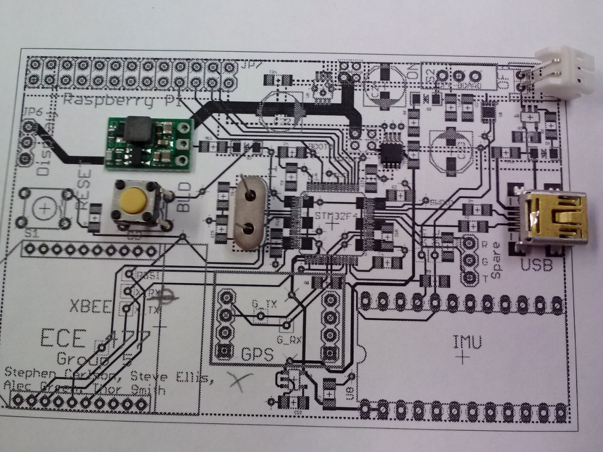

### PCB Continuity and Functionality Test

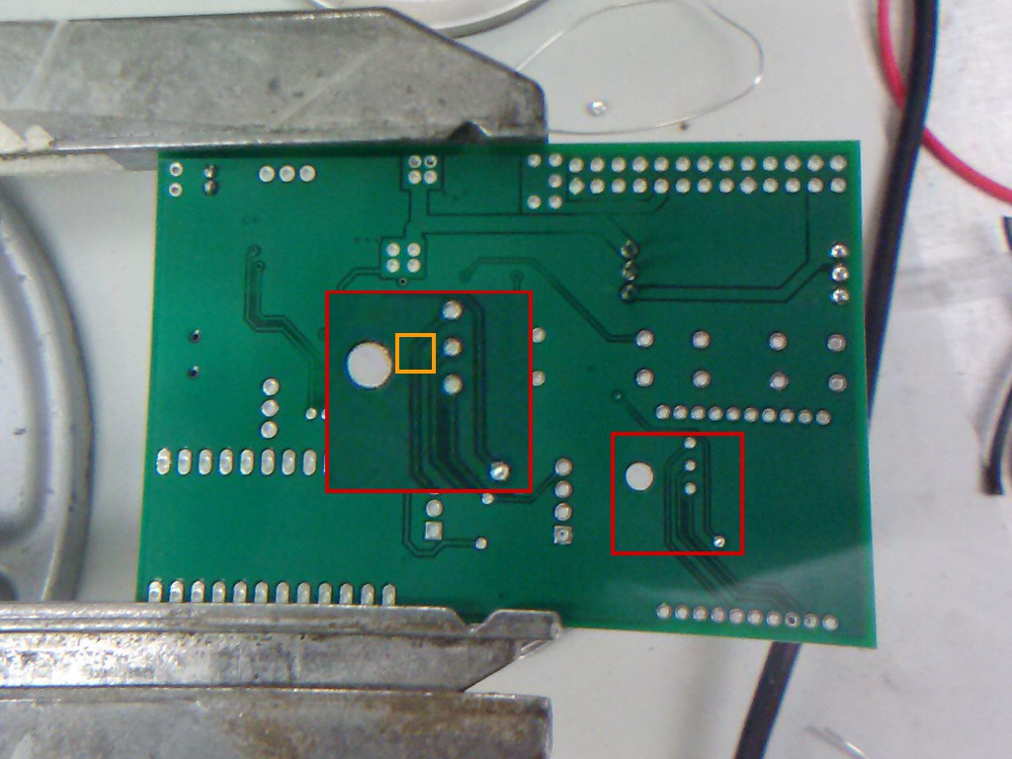

### Power Supply Burn-In

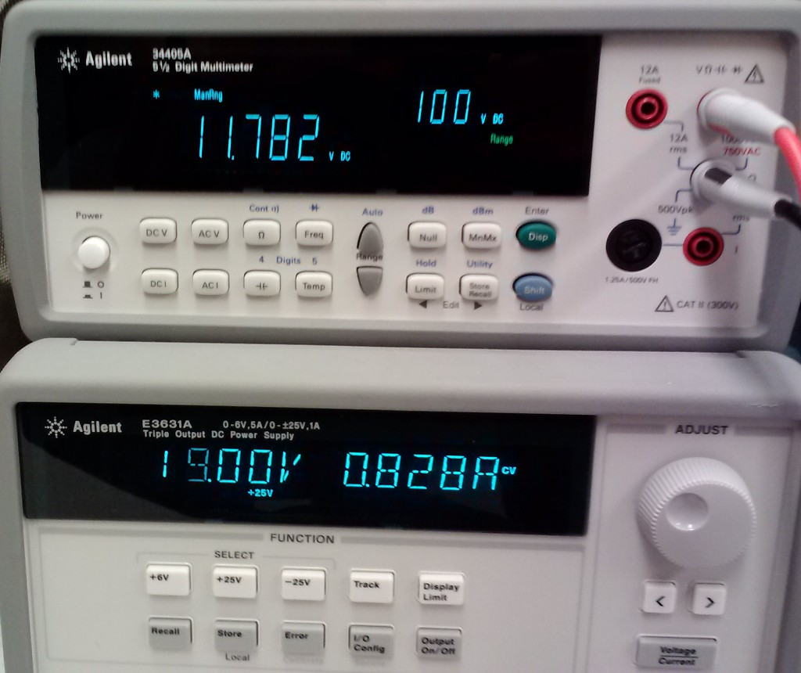

### Total Runtime Test

### Wireless Range Test

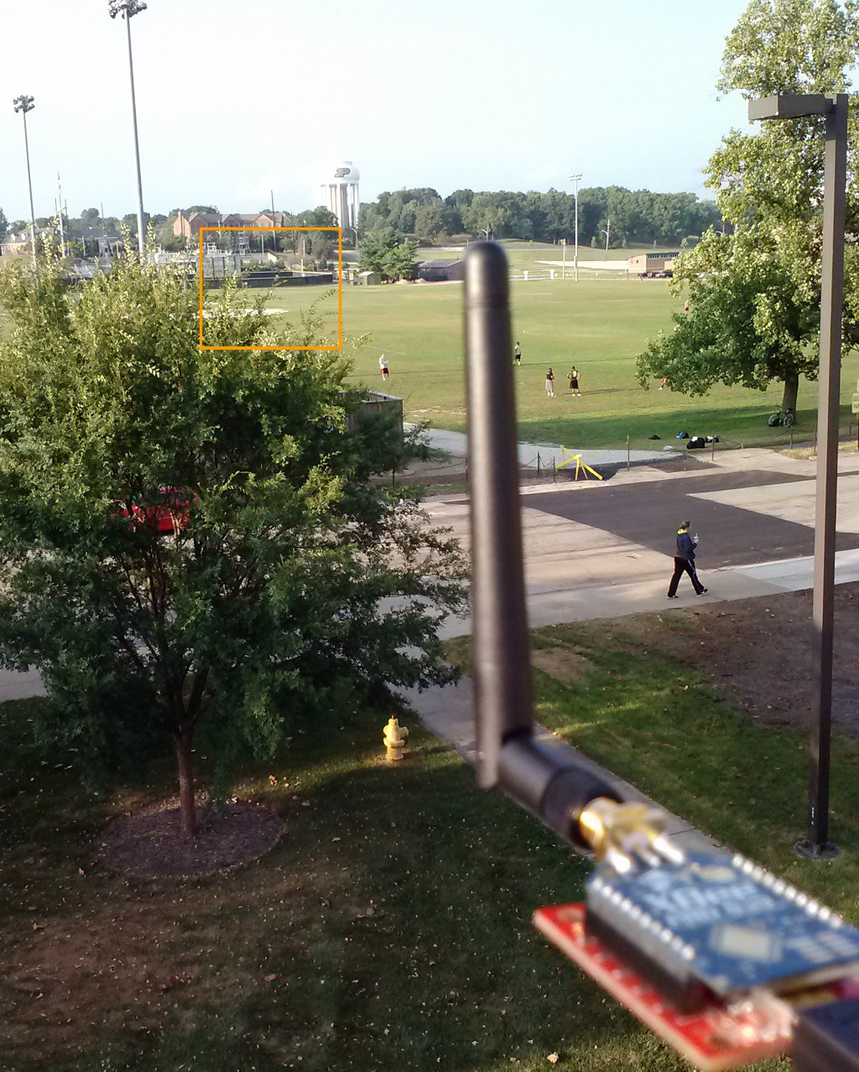

### Wireless Latency Test

[IMAGE: Ping]

### GPS Total Accuracy Test

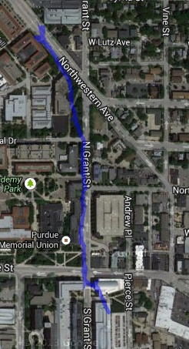

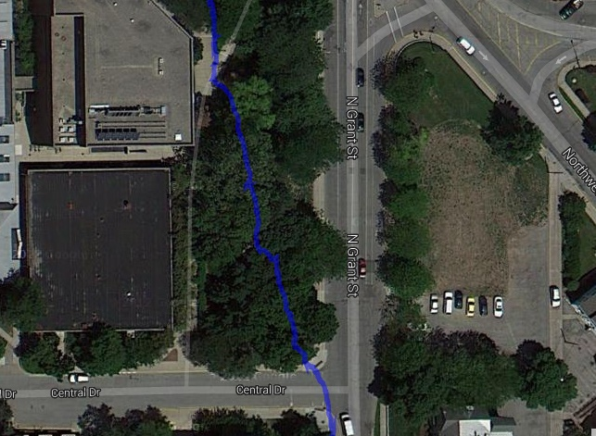

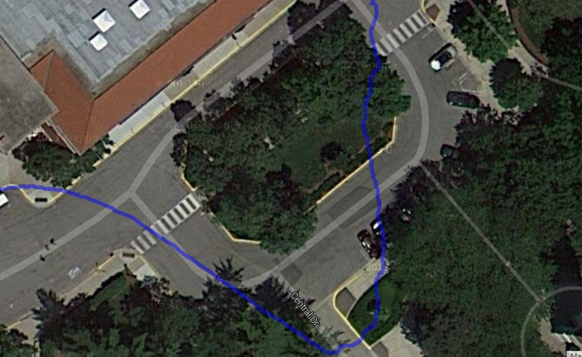

### GPS Relative Accuracy Test

[IMAGE: From Thor]

### Head Tracking Test

[LINK: Youtube video?]

### Brightness, Contrast, and Color Reproduction Test

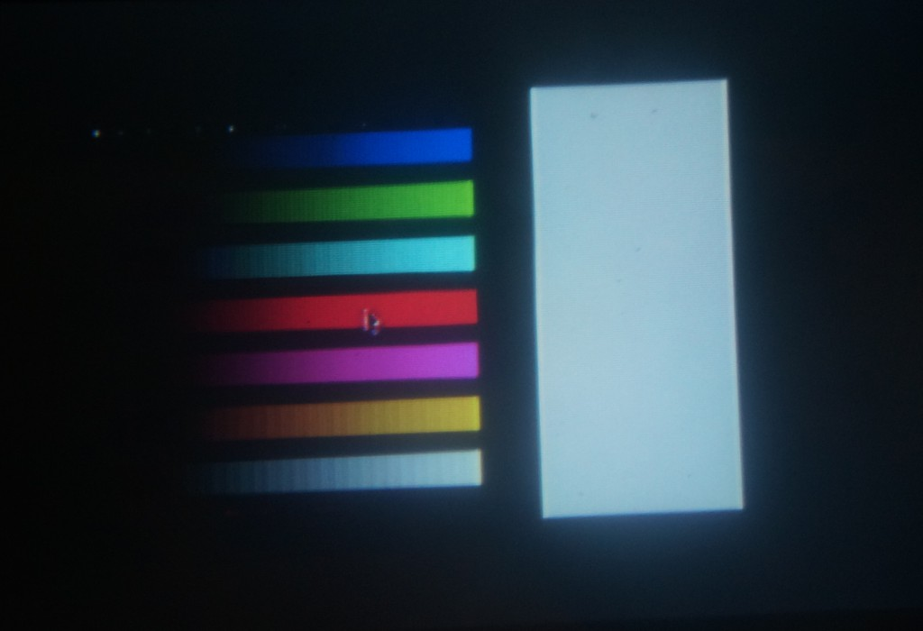

### Maximum Simultaneous Devices Test

[IMAGE: ifconfig, box the bytes sent location, before and after]

### Multiple Headset Test

## Assembly and Construction

Constructing a headset for this project is a fairly simple but quite laborius process. At a high level, the basic steps are to mount a screen and reflector to a suitable enclosure, construct and mount to the helmet a set of aluminum mounting rails, mounting the display assembly to the mounting rails, and then constructing and mounting a sensor enclosure to the rails.

### Rail Assembly

Due to the difficult of mounting hardware directly to a hard hat, a system of rails must first be mounted to facilitate the rest of construction. The material used will be aluminum angle bar with 1/8” thickness and ½” length.

### Display Assembly

This part will vary quite a lot depending on the type of display being used and how it will need to be mounted. We have created headsets using two different displays and the procedures for earch were drastically different.

### Reflector

To achieve the desired augmented reality effect, a sheet of semi-transparent, semi-reflective material is required. In this case it will be a sheet of polycarbonate with a reflective film applied on one side, and a tint film applied to the other side to mitigate brightness issues. A sheet of approximately 6”x4”x1/8” must be cut out. Several holes must be drilled for mounting purposes. Two will be near the bottom corners, which will be used for wire loops to hold the reflector at the correct angle. Four more will be along the top edge, for hinges which secure the reflector to the front of the headset. After the sheet has been cut to the correct size and the holes drilled, a sheet of reflective film the same size as the plastic needs to be cut out and applied as per the directions supplied with film. Then the tint film is to be applied to the other side in the same way. Be mindful that the reflective side needs to be facing the user once everything is assembled.

### Sensor Assembly

The sensors used to measure the user’s location and head orientation reside on their own circuit board which must be mounted to the headset. This is accomplished by mounting the PCB inside of its own enclosure and mounting that enclosure to the rear portion of the rail assembly on the headset. The enclosure used will be a 5”x2.5”x2” ABS project box.

### Mounting the PCB to the enclosure

In order to mount the PCB to the enclosure, several holes will first need to be drilled.

### Mounting the enclosure to the rail

### Materials required

Table 14: Materials required for assembly of headset packaging

|  |  |
| --- | --- |
| Material | Quantity |
| Hard Hat | 1 |
| Angle aluminum, 1/8” thickness, ½” leg | 3 feet |
| Project Box, 4”x6”x2” | 1 |
| Project Box, 5”x2.5”x2” | 1 |
| Zip ties | 25 |
| Screws | 10 |

## Schematic Diagrams

## Printed Circuit Board Layouts

## Failure Mode Worksheet

A failure modes, effects, and criticality analysis (FMECA) worksheet examines the possible failure modes of the device given a failure of one of its parts. For each potential failure, the effects and criticality is stated. A high-criticality failure is likely to injure the user, while a failure which causes the device to simply cease operating is low criticality. Medium criticality failures may involve a display that appears functional but distracts the user with flashing images or intermittent failures which may not be obvious to a non-technical user.

Table 15: FMECA worksheet for power supply and battery charging

|  |  |  |  |  |  |
| --- | --- | --- | --- | --- | --- |
| **Failure Mode** | **Possible Causes** | **Effects** | **Detection Method** | | **Criticality** |
| VIN shorted to GND | Failure of U6, U5, U4, battery protection circuit | Device overheats; fire or explosion may occur | Observation | | High |
| VUSB shorted to VBAT | Failure of U3 and battery protection circuit | Battery is overcharged; fire or explosion may occur | Observation | | High |
| VADC > 3.3 V | Failure of U6, VIN shorted to VADC | IMU reports invalid values or is damaged | User head rotation is ignored | | Low |
| VCORE > 3.3 V | Failure of U5, VIN shorted to VCORE | Motherboard crashes or is damaged | Blank or static display | | Low |
| VMCU > 3.3 V | Failure of U6, VIN shorted to VMCU | Microcontroller crashes or is damaged | Blank or static display | | Low |
| Battery monitor fails | Failure of U2 | Reported battery charge is incorrect | Battery charge indicator invalid | Low | |

Table 16: FMECA worksheet for processing units and sensors

|  |  |  |  |  |
| --- | --- | --- | --- | --- |
| **Failure Mode** | **Possible Causes** | **Effects** | **Detection Method** | **Criticality** |
| Controller crashes | Failure of C1-C13, R2, Y1, U1 | Microcontroller computes invalid data | Corrupt display | Medium |
| Graphics processor crashes | Failure of JP7, U5, components on motherboard | Motherboard produces invalid image | Corrupt display | Medium |
| Controller fails to start | Failure of C1-C13, R2, Y1, U1 | Microcontroller sends no data to motherboard | Blank or static display | Low |
| Graphics processor fails to start | Failure of JP7, U5, components on motherboard | Motherboard does not produce an image | Blank display | Low |
| Display does not function | Failure of display driver board or cables | Image is not displayed to the user | Blank display | Low |
| IMU data invalid or missing | Failure of U6, U7, C12-C13, C19 | Calculated user head orientation is incorrect | Invalid display, virtual heading is wrong | Low |
| GPS data invalid or missing | Failure of JP4, JP5, U4, GPS unit | Calculated user geospatial position is incorrect | Invalid display, virtual position is wrong | Low |